**Android** is a [Linux](http://en.wikipedia.org/wiki/Linux)-based [operating system](http://en.wikipedia.org/wiki/Mobile_operating_system) designed primarily for [touchscreen](http://en.wikipedia.org/wiki/Touchscreen" \o "Touchscreen) mobile devices such as [smartphones](http://en.wikipedia.org/wiki/Smartphone" \o "Smartphone) and [tablet computers](http://en.wikipedia.org/wiki/Tablet_computer). Initially developed by Android, Inc., which [Google](http://en.wikipedia.org/wiki/Google) backed financially and later purchased in 2005, Android was unveiled in 2007 along with the founding of the [Open Handset Alliance](http://en.wikipedia.org/wiki/Open_Handset_Alliance): a consortium of [hardware](http://en.wikipedia.org/wiki/Computer_hardware), [software](http://en.wikipedia.org/wiki/Software), and [telecommunication](http://en.wikipedia.org/wiki/Telecommunication) companies devoted to advancing [open standards](http://en.wikipedia.org/wiki/Open_standard) for mobile devices. The first Android-powered phone was sold in October 2008.

Android is [open source](http://en.wikipedia.org/wiki/Open_source) and Google releases the code under the [Apache License](http://en.wikipedia.org/wiki/Apache_License). This open source code and permissive licensing allows the software to be freely modified and distributed by device manufacturers, wireless carriers and enthusiast developers. Additionally, Android has a large community of developers writing applications ("[apps](http://en.wikipedia.org/wiki/Mobile_app)") that extend the functionality of devices, written primarily in a customized version of the [Java](http://en.wikipedia.org/wiki/Java_(programming_language)" \o "Java (programming language))programming language. In October 2012, there were approximately 700,000 apps available for Android, and the estimated number of applications downloaded from [Google Play](http://en.wikipedia.org/wiki/Google_Play), Android's primary app store, was 25 billion.

These factors have allowed Android to become the world's most widely used smartphone platformand the software of choice for technology companies who require a low-cost, customizable, lightweight operating system for [high tech](http://en.wikipedia.org/wiki/High_tech) devices without developing one from scratch.[[17]](http://en.wikipedia.org/wiki/Android_(operating_system)#cite_note-ars5th-17) As a result, despite being primarily designed for phones and tablets, it has seen additional applications on [televisions](http://en.wikipedia.org/wiki/Television), [games consoles](http://en.wikipedia.org/wiki/Games_console) and other electronics. Android's open nature has further encouraged a large community of developers and enthusiasts to use the open source code as a foundation for community-driven projects, which add new features for advanced users or bring Android to devices which were officially released running other operating systems.

Android had a worldwide smartphone market share of 75% during the third quarter of 2012, with 500 million devices activated in total and 1.3 million activations per day. The operating system's success has made it a target for patent litigation as part of the so-called "[smartphone wars](http://en.wikipedia.org/wiki/Smartphone_wars" \o "Smartphone wars)" between technology companies.

What is android ? This is a simple question but the answer is quite complicated. If you go deeper on the word android , You will get lot of answers for the question What is Android. To answer in a simple way. Android is an operating system for Mobile phones. I will explain more about this in the later part of this article.

Lot of advances can be seen these days in the field of smartphones. As the number of users is increasing day by day, facilities are also increasing. Starting with simple phones which were made just to make and receive calls. Now we have phones which can even access GPS , GPRS, Wifi, NFC. and lot of other cool and advanced features which you cannot even imagine.

So in this Mobile world of this complication. Android is one of those operating system platforms which made it easy for manufacturers to design top class phones.

You might have seen windows , linux and mac operating systems which are made for computers. Windows is the most popular operating system on computers. So if you know about it then it is easy for you to get an answer for what is android.

Android is also an operating system developed by [Google](http://www.google.com/). Basically it was started by some other company which was taken by Google. Google improved the operating system and made it a open source platform. It was widely adapted over the world. As it is open source it is so popular amongst the smartphones.Â  Android OS can also be used on tablet PCs.

Android is based on **linux** and offers you a great deal of customization in widgets and over millions of apps. Most of them are free of cost and can be installed on your phone just by clicking on install tab of the respective app in the Google Play Store app. Which comes along with the android Phone.

You can see the logo of Android from the image below:

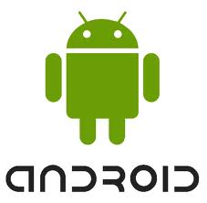

Android is a open source platform which can be used by any phone manufacturers on the world. Unlike other operating systems for mobile phones like iOS ( Operating system by apple for iPhone, iPad and other iDevices.). Symbain is owned by Nokia and it comes only on Nokia Handsets. Android can be used by any manufacturer. So that if the latest research is to be believed over half of the smart phones in usa run on android.

Android is one the hottest mobile operating systems available today. Samsung is the Largest Manufacturer of android phones and tablets. LG, HTC, Sony, are other top manufacturers of android phones and tablets. Some local manufacturers like Micromax, Karbon, Hawai, also use android Phones on their portable devices.

Android is released in series of Versions. Starting from 1.0 version ( where 2.0, 3.0, …… are latest releases). Google name these versions with some food items like ice cream, jelly bean, sandwich etc. which is one of the specialty of android versions.

Here are some of the Versions released by android.

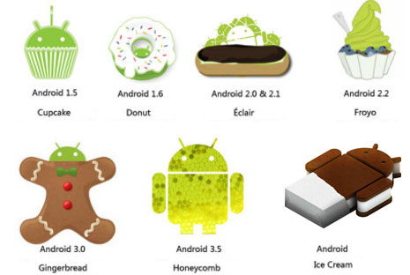

* + 1.0 – Android beta.
  + Â 1.5 – Android Cupcake.
  + Â 1.6 – Android Donut.
  + 2.0/2.1 – Eclair.
  + 2.2.x – Froyo.
  + 2.3.x – Gingerbread.
  + 3.x – Honeycomb (used mainly for tablets.)
  + 4.0.x – Ice Cream Sandwich (both for phones and tablets.)

Android is a software stack for mobile devices that includes an operating system,   
middleware and key applications. Android is a software platform and operating system for   
mobile devices based on the Linux operating system and developed by Google and the Open   
Handset Alliance. It allows developers to write managed code in a Java-like language that   
utilizes Google-developed Java libraries, but does not support programs developed in native   
code. The unveiling of the Android platform on 5 November 2007 was announced with the   
founding of the Open Handset Alliance, a consortium of 34 hardware, software and telecom   
companies devoted to advancing open standards for mobile devices. When released in 2008,   
most of the Android platform will be made available under the Apache free-software and open-  
source license.

Open - Android allows to access core mobile device functionality through standard API   
calls. All applications are equal - Android does not differentiate between the phone's basic and   
third-party applications -- even the dialer or home screen can be replaced. Breaking down   
boundaries - Combine information from the web with data on the phone -- such as contacts or   
geographic location -- to create new user experiences. Fast and easy development - The SDK   
contains what need to build and run Android applications, including a true device emulator and   
advanced debugging tools.

2.2 THE BIRTH OF ANDROID

2.2.1 Google Acquires Android Inc.

In July 2005, Google acquired Android Inc., a small startup company based in Palo Alto,   
CA. Android's co-founders who went to work at Google included Andy Rubin (co-founder of   
Danger), Rich Miner (co-founder of Wildfire Communications, Inc), Nick Sears (once VP at T-  
Mobile), and Chris White (one of the first engineers at WebTV). At the time, little was known   
about the functions of Android Inc. other than they made software for mobile phones.

2.2.2 Open Handset Alliance Founded

On 5 November 2007, the Open Handset Alliance, a consortium of several companies which include Google, HTC, Intel, Motorola, Qualcomm, T-Mobile, Sprint Nextel and NVIDIA, was unveiled with the goal to develop open standards for mobile devices. Along with the formation of the Open Handset Alliance, the OHA also unveiled their first product, Android, an open source mobile device platform based on the Linux operating system.

2.2.3 Hardware

Google has unveiled at least three prototypes for Android, at the Mobile World Congress   
on February 12, 2008. One prototype at the ARM booth displayed several basic Google   
applications. A’d-pad' control zooming of items in the dock with a relatively quick response.

2.3 FEATURES OF ANDROID OPERATING SYSTEM

Application framework enabling reuse and replacement of components

Dalvik virtual machine optimized for mobile devices

Integrated browser based on the open source WebKit engine

Optimized graphics powered by a custom 2D graphics library; 3D graphics based

on the OpenGL ES 1.0 specification (hardware acceleration optional)

SQLite for structured data storage

Media support for common audio, video, and still image formats (MPEG4,

H.264, MP3, AAC, AMR, JPG, PNG, GIF)

GSM Telephony (hardware dependent)

Bluetooth, EDGE, 3G, and Wi-Fi (hardware dependent)

Camera, GPS, compass, and accelerometer (hardware dependent)

Rich development environment including a device emulator, tools for debugging,

memory and performance profiling, and a plug-in for the Eclipse IDE.

2.4 ANDROID ARCHITECTURE

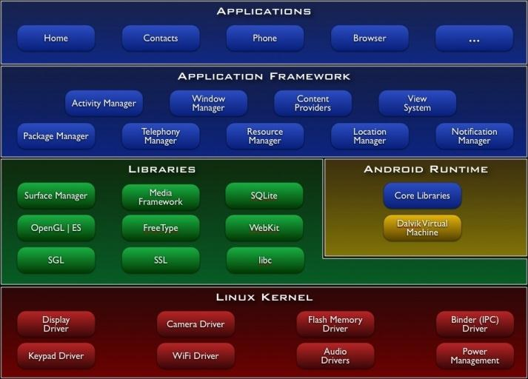

Figure 2.1: Architecture of Android OS

2.4.1APPLICATION FRAMEWORK

Developers have full access to the same framework APIs used by the core applications.   
The application architecture is designed to simplify the reuse of components; any application can   
publish its capabilities and any other application may then make use of those capabilities (subject   
to security constraints enforced by the framework). This same mechanism allows components to

Underlying all applications is a set of services and systems, including:

A rich and extensible set of Views that can be used to build an application, including   
lists, grids, text boxes, buttons, and even an embeddable web browser.

Content Providers that enable applications to access data from other applications (such   
as Contacts), or to share their own data.

A Resource Manager, providing access to non-code resources such as localized strings, graphics, and lat files.

A Notification Manager that enables all applications to display custom alerts in the   
status bar.

An Activity Manager that manages the life cycle of applications and provides a common navigation back stack.

2.4.1 LIBRARIES

Android includes a set of C/C++ libraries used by various components of the Android system. These capabilities are exposed to developers through the Android application framework. Some of the core libraries are listed below:

System C library - a BSD-derived implementation of the standard C system library   
 (libc), tuned for embedded Linux-based devices.

Media Libraries - based on Packet Video’s Open CORE; the libraries support playback   
 and recording of many popular audio and video formats, as well as static image files,   
 including MPEG4, H.264, MP3, AAC, AMR, JPG, and PNG.

Surface Manager - manages access to the display subsystem and seamlessly composites   
 2D and 3D graphic layers from multiple applications.

LibWebCore - a modern web browser engine which powers both the Android browser and an embeddable web view.

SGL - the underlying 2D graphics engine.

3D libraries - an implementation based on OpenGL ES 1.0 APIs;

Free Type - bitmap and vector font rendering.

SQLite- a powerful and lightweight relational database engine available to all

applications.

2.4.2 ANDROID RUNTIME

Android includes a set of core libraries that provides most of the functionality available in the core libraries of the Java programming language. Every Android application runs in its own process, with its own instance of the Dalvik virtual machine. Dalvik has been written so that a device can run multiple VMs efficiently. The Dalvik VM executes files in the Dalvik Executable (.dex) format which is optimized for minimal memory footprint. The VM is register-based, and runs classes compiled by a Java language compiler that have been transformed into the .dex format by the included "dx" tool. The Dalvik VM relies on the Linux kernel for underlying functionality such as threading and low-level memory management.

At the same level there is Android Runtime, where the main component Dalvik Virtual Machine is located. It was designed specifically for Android running in limited environment, where the limited battery, CPU, memory and data storage are the main issues. Android gives an integrated tool ―dx‖, which converts generated byte code from .jar to .dex file, after this byte code becomes much more efficient to run on the small processors.

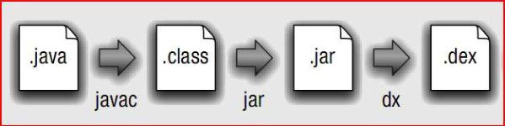

Following these guidelines, it’s possible to integrate existing Java source code, packages   
and libraries piecemeal. Special care will be needed in the integration phase of such code but the   
potential savings offered by such integration far outweighs the cost of rewriting well-coded,

well-documented and well-tested libraries ready for use. Furthermore, it is expected that has Apache Harmony matures, more and more compatibility issues will be resolved further increasing the pool of available Java code that will be able to execute unmodified under the Android platform.

2.4.4.1 The Dalvik Virtual Machine

The Dalvik virtual machine is an interpreter only machine optimized for use on low   
powered, low memory devices like phones. Notably, Dalvik does not make use of just in time   
(JIT) Compilation to improve the performance of an application at runtime. Furthermore, Dalvik   
is not a Java virtual machine. This is because Dalvik is unable to read Java bytecode34; instead it   
uses its own bytecode format called ―dex‖. Google claims this format allows battery power to be   
better-conserved at all different stages of execution of an application. This means that standard   
Java SE applications and libraries cannot be used directly on the Android Dalvik virtual machine.   
Dalvik however stands at the centre of the Android value proposition. Its low electrical power   
consumption, rich libraries, and unified, non-fragmented application programming interfaces   
make it stand out, or so Google hopes, over the fragmented ecosystem that is Java ME35 today.   
Furthermore, since Dalvik uses the Java programming language but not the Java execution   
environment (JVM), Google is free to develop Android without the need to license or obtain   
certification from Sun Microsystems Inc, the legal owner of the Java trademark and brands.

LIFE CYCLE OF AN ANDROID APPLICATION

In most cases, every Android application runs in its own Linux process. This process is   
created for the application when some of its code needs to be run, and will remain running until   
it is no longer needed and the system needs to reclaim its memory for use by other applications.

An important and unusual feature of Android is that an application process's lifetime is not directly controlled by the application itself. Instead, it is determined by the system through a combination of the parts of the application that the system knows are running, how important these things are to the user, and how much overall memory is available in the system.

It is important that application developers understand how different application components (in particular Activity, Service, and IntentReceiver) impact the lifetime of the application's process. Not using these components correctly can result in the system killing the application's process while it is doing important work.

A common example of a process life-cycle bug is an IntentReceiver that starts a thread when it receives an Intent in its onReceiveIntent() method, and then returns from the function.

Once it returns, the system considers that IntentReceiver to be no longer active, andthus its hosting process no longer needed (unless other application components are active in it). Thus, it may kill the process at any time to reclaim memory, terminating the spawned thread that is running in it. The solution to this problem is to start a Service from the IntentReceiver, so the

system knows that there is still active work being done in the process. To determine which processes should be killed when low on memory, Android places them into an "importance hierarchy" based on the components running in them and the state of those components. These are, in order of importance:

1. A foreground process is one holding an Activity at the top of the screen that the user is interacting with (its onResume () method has been called) or an IntentReceiver that is currently running (its onReceiveIntent () method is executing). There will only ever be a few such processes in the system, and hese will only be killed as a last resort if memory is so low that not even these processes can continue to run. Generally at this point the device has reached a memory paging state, so this action is required in order to keep the user interface responsive.

2. A visible process is one holding an Activity that is visible to the user on-screen but not in the foreground (its onPause() method has been called). This may occur, for example, if the foreground activity has been displayed with a dialog appearance that allows the previous activity to be seen behind it. Such a process is considered extremely important and will not be killed unless doing so is required to keep all foreground processes running.

3. A service process is one holding a Service that has been started with the startService() method. Though these processes are not directly visible to the user, they are generally doing things that the user cares about (such as background mp3 playback or background network data upload or download), so the system will always keep such processes running unless there is not enough memory to retain all foreground and visible process.

4. A background process is one holding an Activity that is not currently visible to the user (its onStop() method has been called). These processes have no direct impact on the user experience. Provided they implement their activity life cycle correctly (see Activity for more details), the system can kill such processes at any time to reclaim memory for one of the three previous processes types. Usually there are many of these processes running, so they are kept in

5. An empty process is one that doesn't hold any active application components. The only reason to keep such a process around is as a cache to improve start-up time the next time a component of its application needs to run. As such, the system will often kill these processes in order to balance overall system resources between these empty cached processes and the underlying kernel caches. When deciding how to classify a process, the system picks the most important level of all the components currently active in the process.

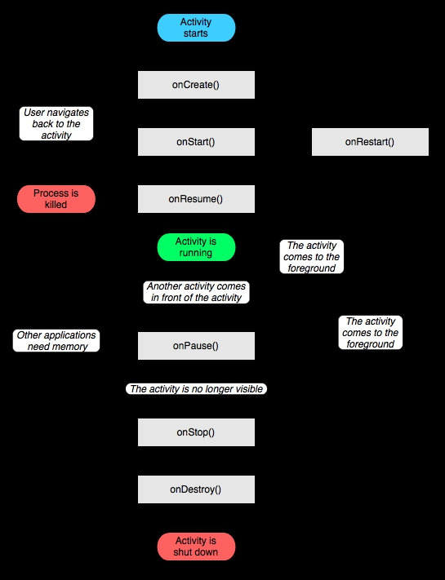

Figure 2.5: Life Cycle of an Activity